1. Introduction
This technical proposal outlines the approach to design, develop, and deploy a cross-platform mobile application supported by a web-based supervisory dashboard, in alignment with the requirements stated in the document.
The system will be developed from scratch, following best practices in mobile application architecture, offline-first design, secure cloud synchronization, and scalable backend services.
The solution will primarily target Android devices, while ensuring architectural readiness for future iOS compatibility, and will be optimized for field-level usage in low-connectivity environments.

2. Project Objectives
The key objectives of the proposed system are:
- Enable field activists to submit cases and relevant data using a mobile application
- Ensure offline data capture with automatic synchronization when internet connectivity becomes available
- Provide supervisors with a dashboard to monitor case submissions, payments, and activist performance
- Implement a compensation calculator to generate monthly payment summaries
- Ensure secure, scalable, and maintainable system architecture
- Deliver a user-friendly and reliable digital solution suitable for targeted audience

3. Proposed Technical Approach

3.1 Overall Solution Strategy
The proposed solution follows an Offline-First, Mobile-Centric Architecture, supported by cloud-based backend services and a web dashboard.
Key design principles include:
- Offline usability as default behavior
- Automatic synchronization
- Separation of concerns between mobile, backend, and dashboard layers
- Scalable and modular system components
- Secure data handling and role-based access

3.2 Mobile Application (Android-First)
The mobile application will be developed primarily for Android devices, considering device diversity, memory limitations, and intermittent connectivity in field environments.
Core features include:
- Secure login for activists
- Offline case data entry and storage
- Media capture (photos, documents) with local caching
- Automatic sync when internet becomes available
- Case submission history and sync status indicators
- Monthly compensation view for individual activists
The architecture will be designed so that iOS compatibility can be enabled in future phases with minimal refactoring.

3.3 Offline Functionality & Cloud Synchronization
The application will use local device storage as the primary data source during offline usage.
Offline behavior includes:
- Case creation and editing without internet
- Temporary local storage of form data and media
- Conflict-aware sync mechanism when connectivity is restored
- Sync retry and failure handling logic
Cloud synchronization will ensure:
- Data consistency between mobile app and dashboard
- Secure API-driven data transfer

3.4 Supervisor Dashboard
A web-based dashboard will be developed to support supervisors and administrators.
Dashboard capabilities include:
- Overview of case submissions
- Monitoring activist activity and performance metrics
- Viewing payment eligibility and compensation summaries
- Filtering by time period, location, and activist
- Exportable reports (CSV / PDF readiness)

3.5 Compensation Calculator
The system will include a rule-based compensation calculator that:
- Calculates payments based on predefined rules
- Generates monthly summaries per activist
- Supports supervisor review and validation
- Ensures traceability between cases and payments
This component will be configurable to accommodate future policy or rate changes without code restructuring.

4. System Architecture Overview

4.1 High-Level Architecture
The system will follow a three-layer architecture:
- Mobile Application Layer
- Backend & API Layer
- Dashboard & Analytics Layer
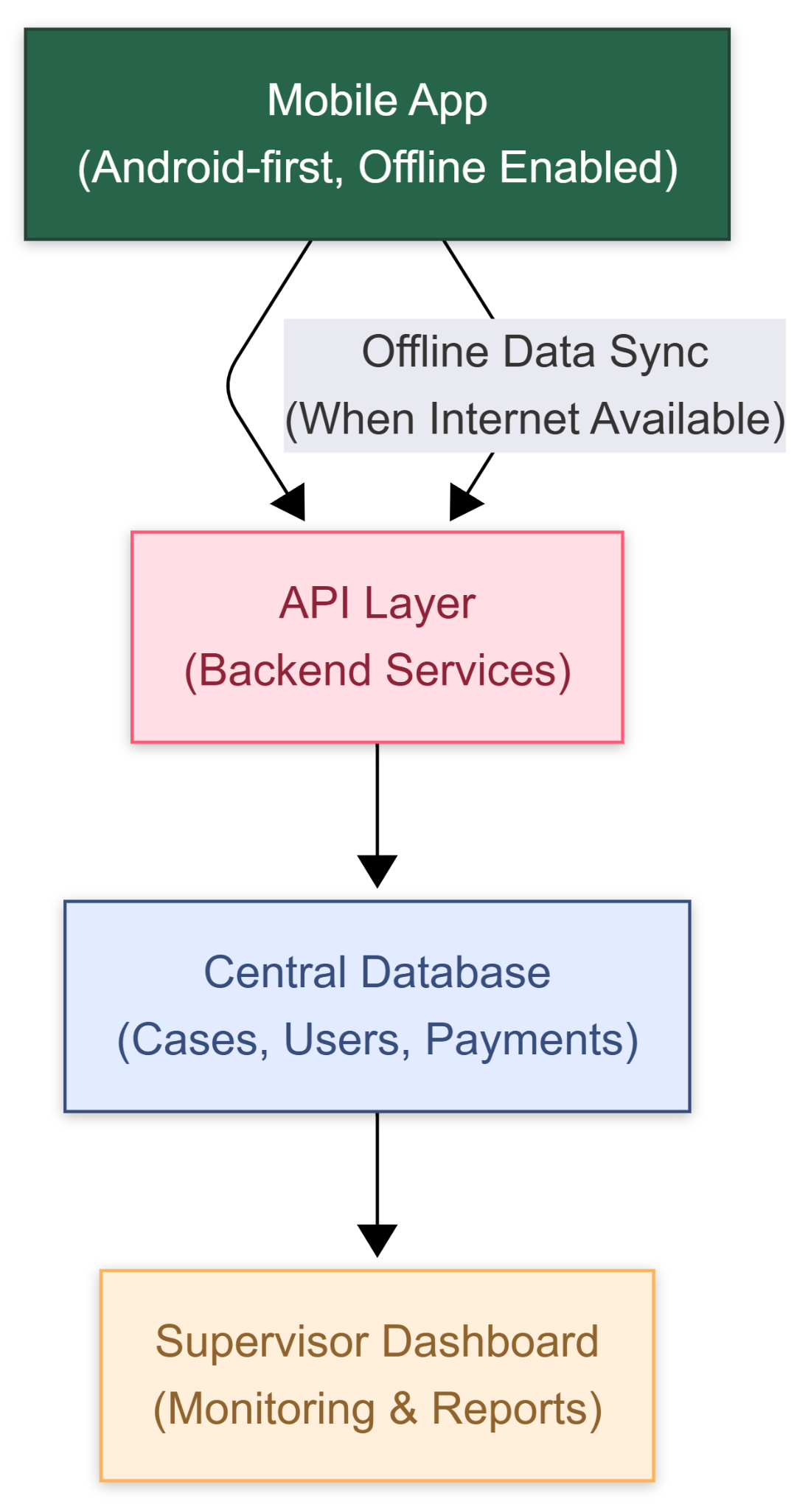

4.2 Data Flow Overview
- Activist submits case data (offline or online)
- Data stored locally if offline
- Sync service pushes data to backend when online
- Backend validates and stores data centrally
- Dashboard fetches data for supervisors
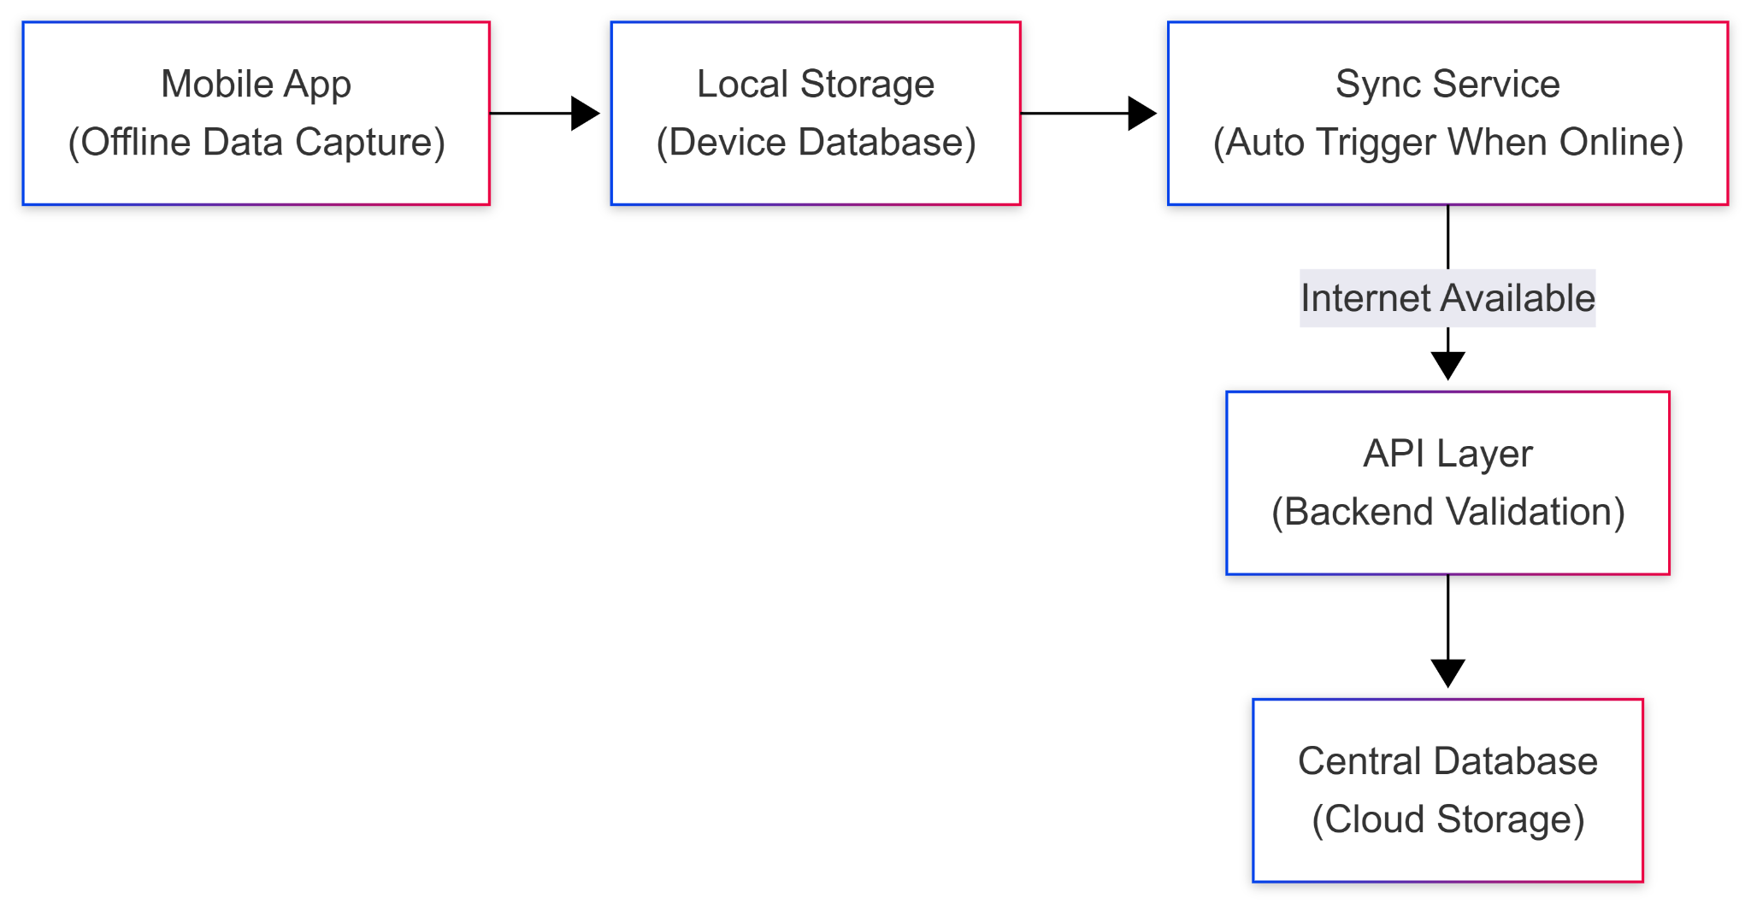

5. Proposed Technical Stack

5.1 Mobile Application
- Framework: Flutter (Android-first, iOS-ready)
- Local Storage: SQLite / Hive
- State Management: Provider / Riverpod

5.2 Backend & APIs
- Backend Framework: Laravel (RESTful API architecture)
- Authentication: JWT-based authentication
- Database: MySQL / PostgreSQL
- Media Storage: Cloud object storage (S3-compatible)

5.3 Supervisor Dashboard
- Frontend Framework: React.js / Vue.js
- Visualization: Chart libraries for performance tracking
- Role Management: Supervisor and Admin access levels

5.4 Cloud & Infrastructure
- Hosting: Cloud-based VPS / Managed hosting
- Environment: Development, Staging, Production

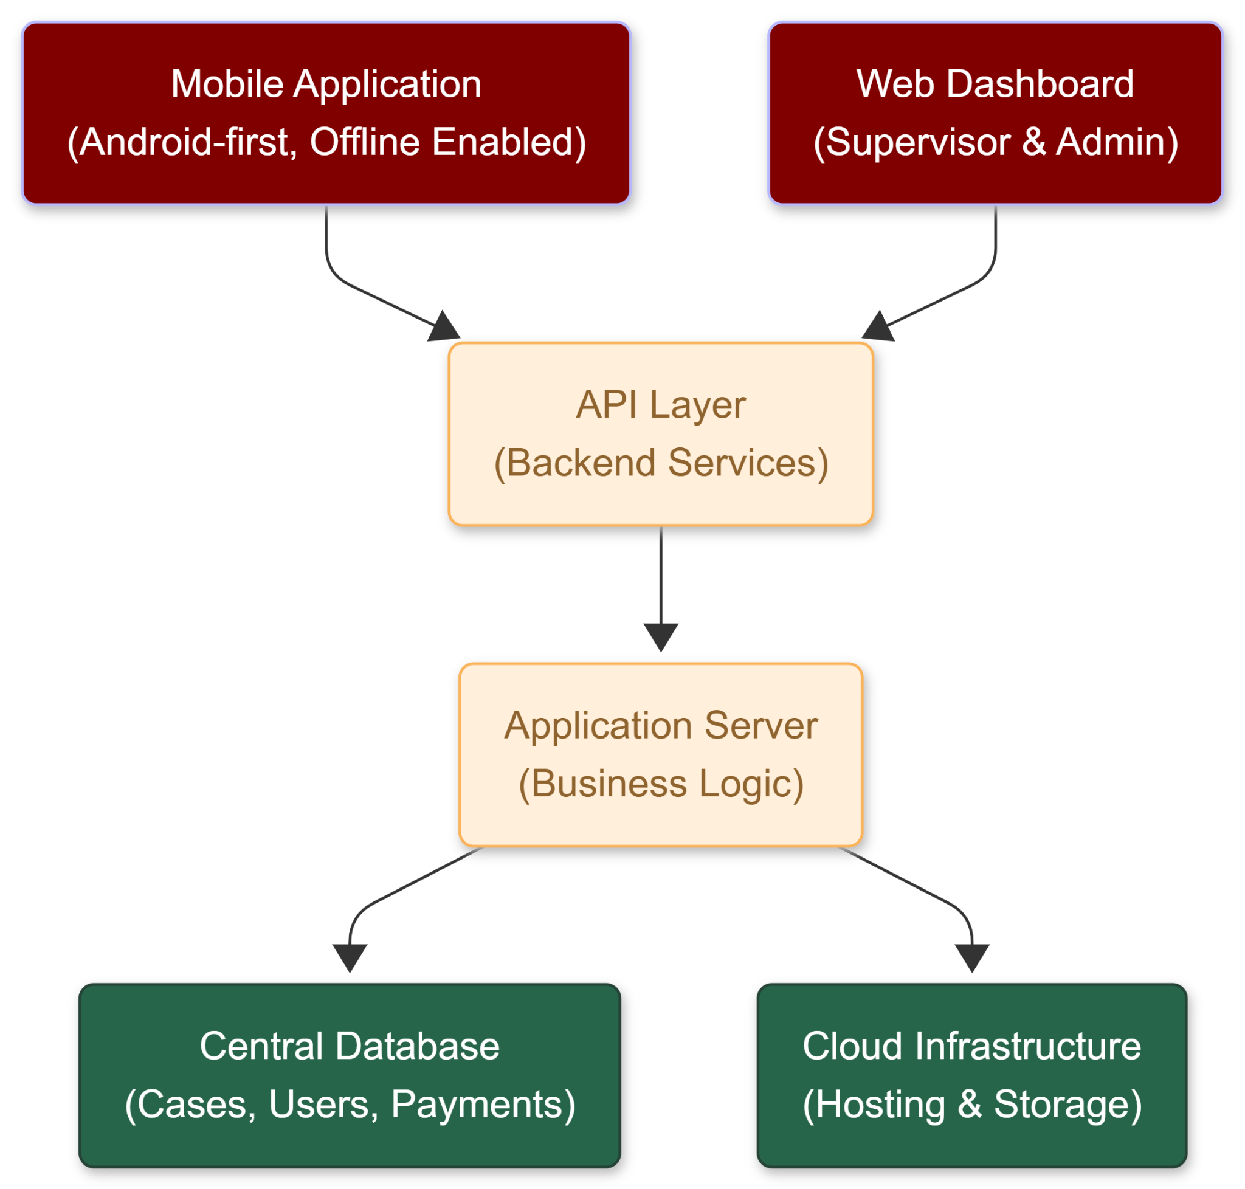

6. Development Methodology
The project will follow an Agile, Iterative Development Methodology to ensure flexibility, transparency, and early validation.

6.1 Methodology Phases
Phase 1: Inception & Requirement Finalization
- Detailed requirement analysis
- User flow validation
- Technical architecture finalization
Phase 2: UI/UX & System Design
- Mobile and dashboard wireframes
- Data models and API contracts
- Offline sync logic design
Phase 3: Development & Integration
- Mobile app development
- Backend API development
- Dashboard development
Phase 4: Testing & Quality Assurance
- Functional testing
- Offline-online sync testing
- Performance and security testing
Phase 5: Deployment & Knowledge Transfer
- Production deployment
- Documentation handover
- Admin and supervisor orientation

7. Security & Data Protection
The system will ensure:
- Secure authentication and authorization
- Encrypted data transmission (HTTPS)
- Controlled access to sensitive data

8. Deliverables
The key deliverables include:
- Android mobile application (production-ready)
- Backend API services
- Supervisor web dashboard
- Compensation calculator module
- Technical documentation
- Deployment and configuration guides
- Post-Launch Support (3 months bug-fixing)

9. Timeline
Overall project duration: 8 weeks

10. Conclusion
The proposed solution delivers a robust, scalable, and offline-ready digital platform, designed specifically for field-level operations and supervisory oversight.
By combining an Android-first mobile application, secure backend services, and a powerful monitoring dashboard, the system ensures operational efficiency, transparency, and future scalability.

